Scam Alert: Beware of Recent Waiting List Scam
Recently, flyers have been circulating on social media advertising assistance with applying for Section 8 funding. The flyer and website www.govassistance.org are NOT legitimate.
The scam aims to take advantage of Housing Choice Voucher (HCV) participants to obtain their personal information to facilitate fraudulent activity.
There are multiple versions of the flyer shown here, on various websites including Facebook, Instagram, and TikTok, typically with slightly changed wording and dates.
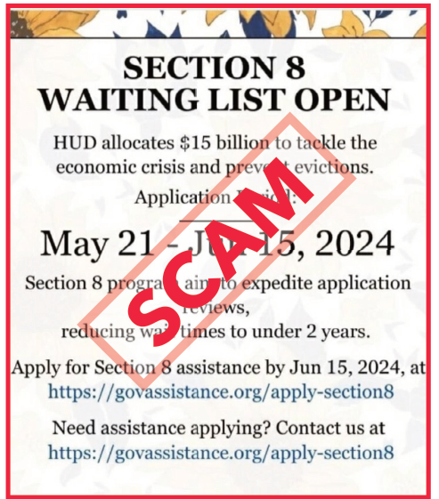

Remember best practices for cybersecurity
- If it seems too good to be true, it probably is.
- NEVER click on a hyperlink if you are unsure if it is legitimate or without verifying with a trusted source.
- NEVER submit Social Security Numbers, bank or credit card information, or other personal details to a website found through an online search.
- NEVER pay to apply for rental assistance. Applications for rental assistance will never have a fee.

Report a scam
Individuals who fall victim to this or similar scams can file a complaint at the Internet Crime Complaint Center (IC3): https://www.ic3.gov/.
If someone reaches out to you about a scam involving HUD, please contact the HUD Computer Incident Response Team (CIRT) at CIRT@hud.gov.
All Sacramento Housing and Redevelopment Agency waiting lists are ONLY posted on Sacwaitlist.com.
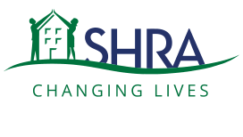
Sacramento Housing and Redevelopment Agency is an Equal Housing Opportunity provider and offers reasonable accommodations for persons with disabilities.

